CLOUD FRONT AND CLOUD FORMATION

* Create S3 bucket
* Upload an object

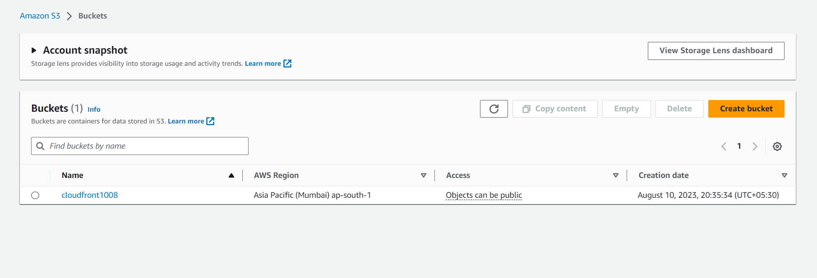

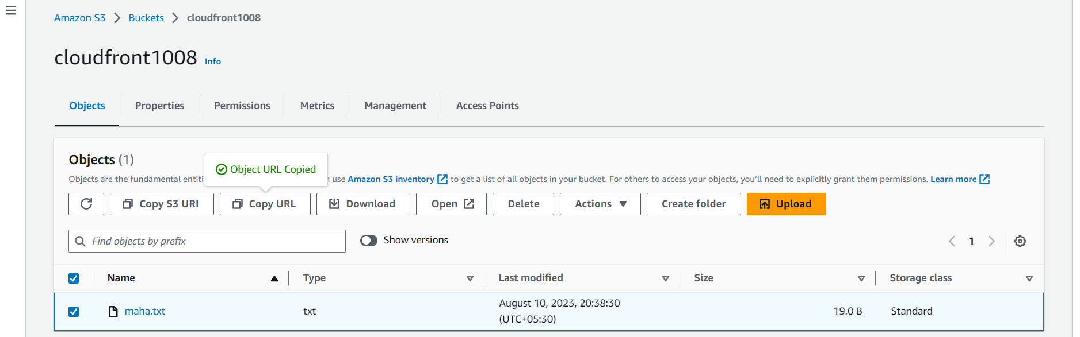

* This is the file I uploaded in S3 bucket

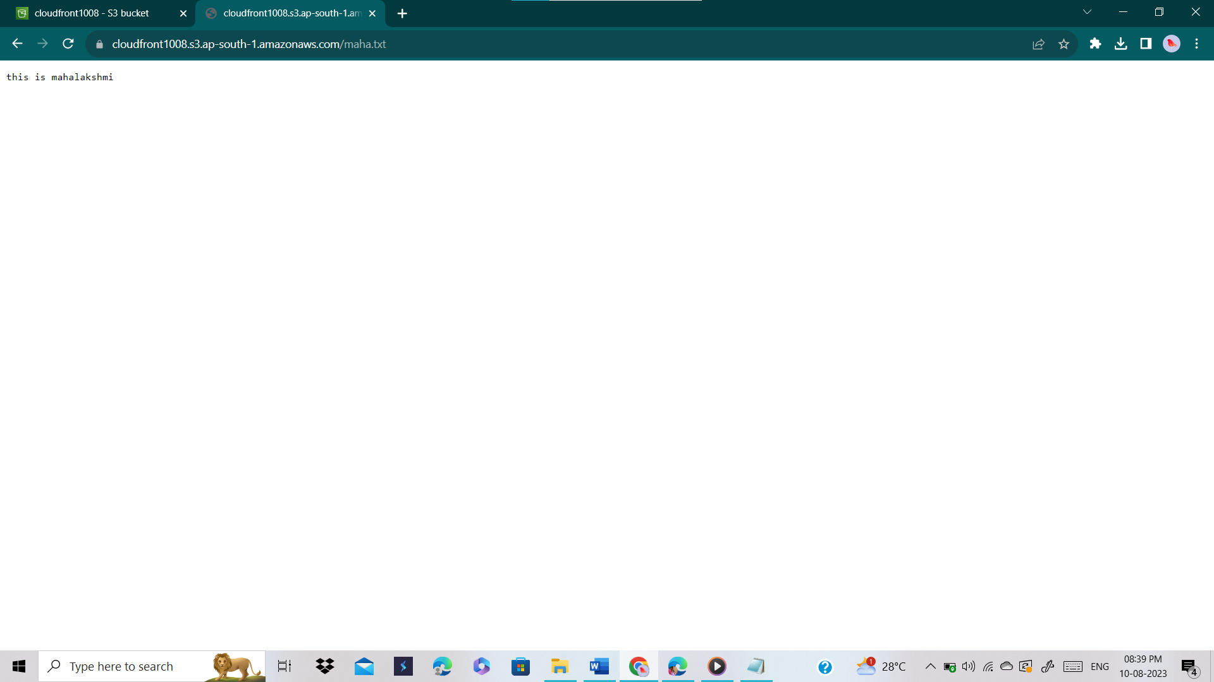

* Create a distribution in cloud front
* Origin shield means it will protect from hacking, it will create an additional cache layer
* Set the TTL (hosting time)
* Web application firewall: do not enable security protections

